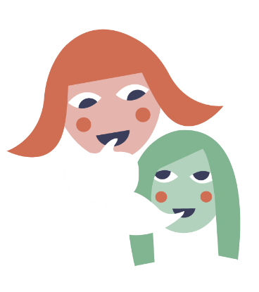

My tribunal hearing
My tribunal hearing will take place on Day X Month and Day X Month Year.

Because of the virus, the tribunal hearing will be virtual with everyone using computers to communicate and see each other.

- During the tribunal hearing, only one person speaks at a time. Everyone else listens to what they have to say.

- The person giving evidence is called the witness. Other people will take it in turns to ask that person questions.

- I can’t interrupt even if I don’t agree with what they are saying. The reason for this is so that everyone has their say.

- After the other witnesses have spoken, on day 2, I will get my chance to be the witness and say what I think and feel and everyone will concentrate and listen to me.

- When it’s my turn to be the witness, I will be asked some questions. The tribunal members just want to know what I think and feel. The questions are not meant to be hard or to trick me.

- Throughout the day there will be several breaks. The hearing will stop no later than 4 o’clock each day.

It’s important for me to remember:

- The people at the tribunal hearing won’t be smiling a lot.

- This doesn’t mean they are angry, annoyed or unfriendly. It means they are concentrating and listening.

- The people won’t be looking at the screen all the time. They will be looking down a lot of the time.
- This doesn’t mean they aren’t concentrating or listening. It is because they are writing down notes so that they remember everything clearly afterwards.

- I will hear a lot of things being said about me and my education. I will probably agree with a lot of it. The witnesses might also say things I disagree with. They might say things that annoy me or upset me.
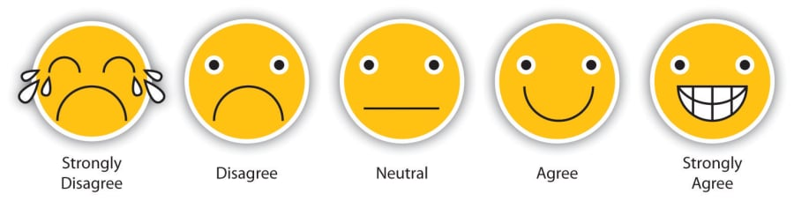
Remember… I can’t interrupt at that point but I know I will get my chance to have my say and put across my point of view later on.

- I can ask for a break. My supporter will be with me to help.

- I can attend my tribunal hearing without feeling too stressed now that I know what it will be like.

